**Supplementary Material**

Temporal and spatial trends of adverse pregnancy and birth outcomes in a sample of births from a public hospital in Chile.

|  |  |
| --- | --- |
| Name | Page number |
| Supplementary Figure 1. Flow diagram of birth records included in the study. | 2 |
| Supplementary Figure 2. Maternal characteristics by year with p-value for trend over time, Temuco, Chile, 2009-2016. | 3 |
| Supplementary Figure 3. Multiple deprivation index (MDI) by neighbourhood, Temuco, Chile, 2009-2016. | 4 |
| Supplementary Figure 4. Spatial distribution of pre-eclampsia, eclampsia, gestational diabetes, hypertensive disorders, tLBW, stillbirth and SGA by neighborhood, Temuco, Chile, 2009-2016. | 5-6 |

Supplementary Figure 1. Flow diagram of birth records included in the study.

Supplementary Figure 2. Maternal characteristics by year with p-value for trend over time, Temuco, Chile, 2009-2016.

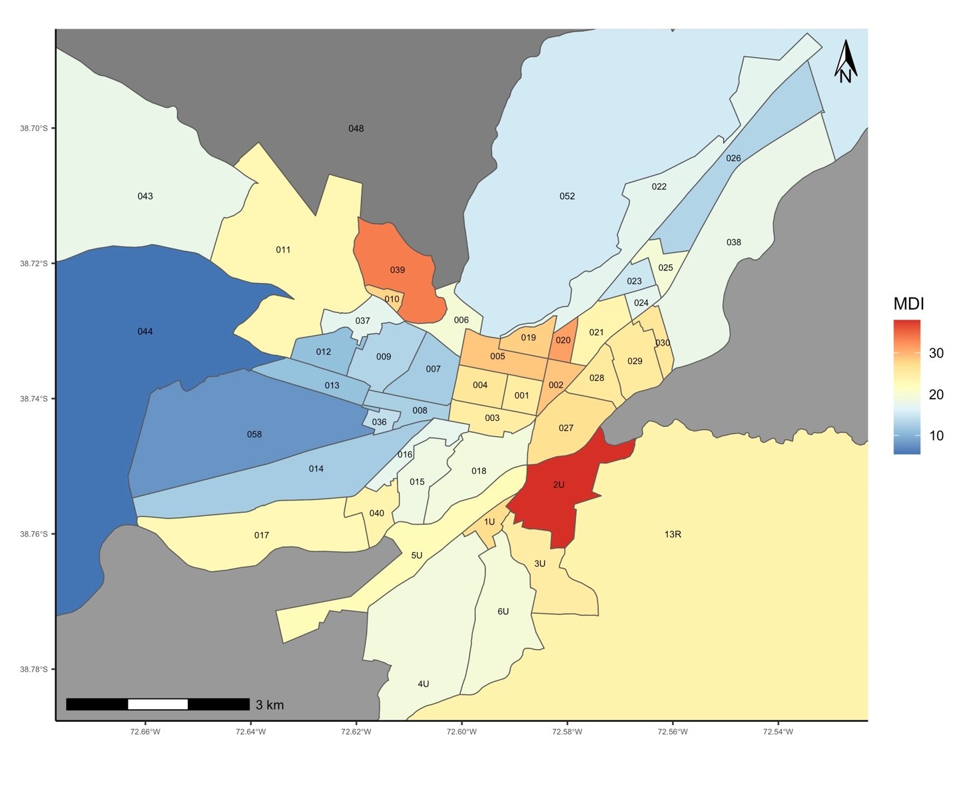

Neighborhoods:

|  |  |  |  |
| --- | --- | --- | --- |
| IU- Villa Alegre | 006- Pedro de Valdivia | 018- Pichi Cautín | 029- Santa Rosa |
| 2U- La Unión | 007- Los Jardines | 019- Lourdes | 030- Pomona |
| 3U- Alianza | 008- Dreves | 020- Tucapel | 036- Estadio |
| 4U- Thiers | 009- Sofo | 021- Maestranza | 037- Campos Deportivos |
| 5U- Ribereños | 010- Los Laureles | 022- 5 de abril | 038- Villa Turingia |
| 6U- Manquehue | 011- Tromen | 023- Ernesto Bohn | 039- Vista Hermosa |
| 001- Central | 012- Igualdad y Trabajo | 024- Ñielol | 040- Villa Sur |
| 002- Estación | 013- Millaray | 025- Evaristo Marín | 043- Tromen Molulco |
| 003- Las Heras | 014- Universidad | 026- Porvenir | 044-Botrolhue |
| 004- Caupolicán | 015- Las Quilas | 027- San Antonio | 050- Pumalal |
| 005- Balmaceda | 016- Imperial | 028- Paredes | 058- José Miguel Carrera |

Supplementary Figure 3. Multiple deprivation index (MDI) by neighborhood, Temuco, Chile, 2009-2016.

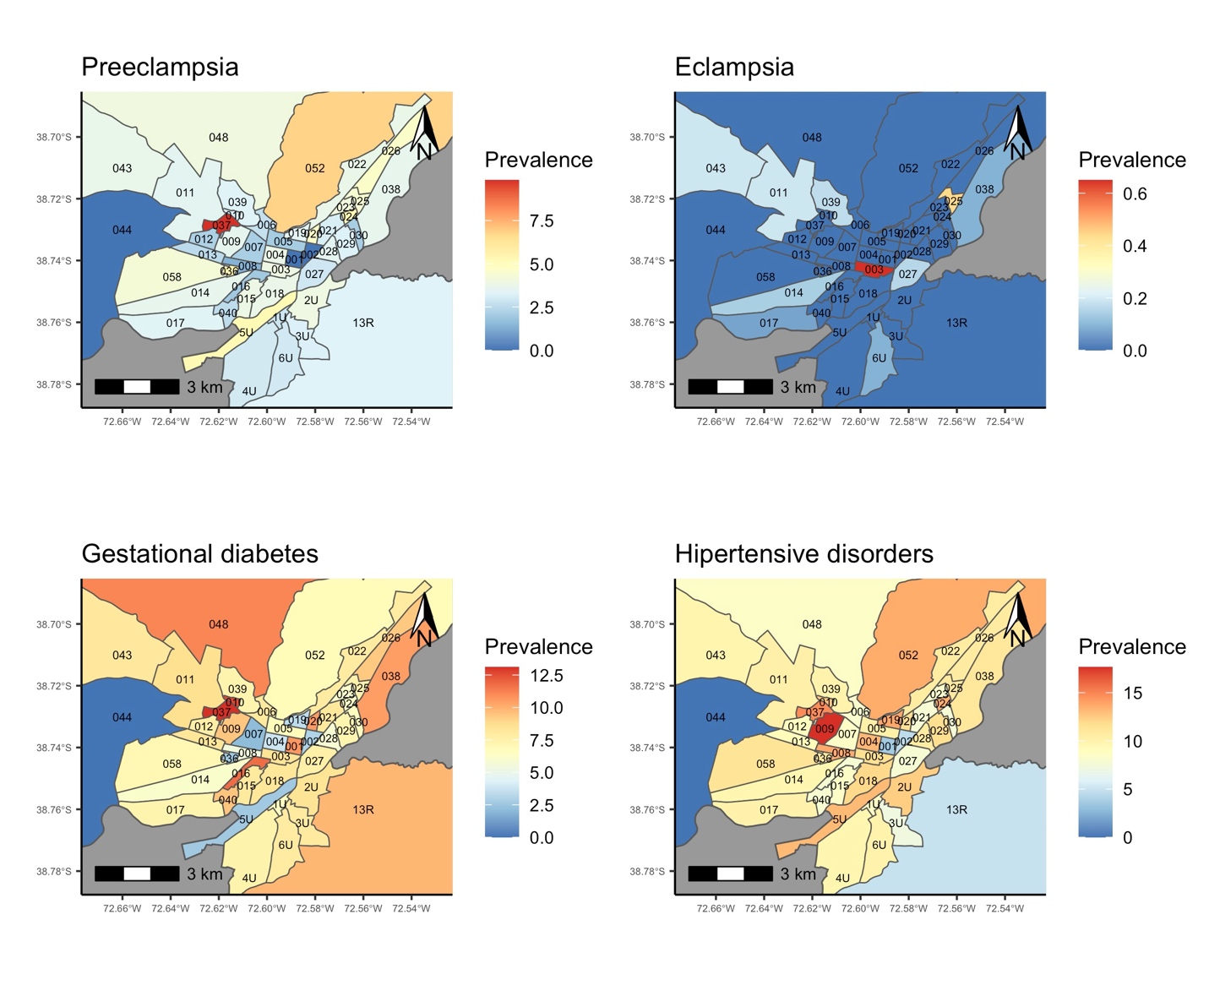

Neighborhoods:

|  |  |  |  |
| --- | --- | --- | --- |
| IU- Villa Alegre | 006- Pedro de Valdivia | 018- Pichi Cautín | 029- Santa Rosa |
| 2U- La Unión | 007- Los Jardines | 019- Lourdes | 030- Pomona |
| 3U- Alianza | 008- Dreves | 020- Tucapel | 036- Estadio |
| 4U- Thiers | 009- Sofo | 021- Maestranza | 037- Campos Deportivos |
| 5U- Ribereños | 010- Los Laureles | 022- 5 de abril | 038- Villa Turingia |
| 6U- Manquehue | 011- Tromen | 023- Ernesto Bohn | 039- Vista Hermosa |
| 001- Central | 012- Igualdad y Trabajo | 024- Ñielol | 040- Villa Sur |
| 002- Estación | 013- Millaray | 025- Evaristo Marín | 043- Tromen Molulco |
| 003- Las Heras | 014- Universidad | 026- Porvenir | 044-Botrolhue |
| 004- Caupolicán | 015- Las Quilas | 027- San Antonio | 050- Pumalal |
| 005- Balmaceda | 016- Imperial | 028- Paredes | 058- José Miguel Carrera |

Supplementary Figure 4. Spatial distribution of pre-eclampsia, eclampsia, gestational diabetes, hypertensive disorders, tLBW, stillbirth and SGA by neighbourhood, Temuco, Chile, 2009-2016.

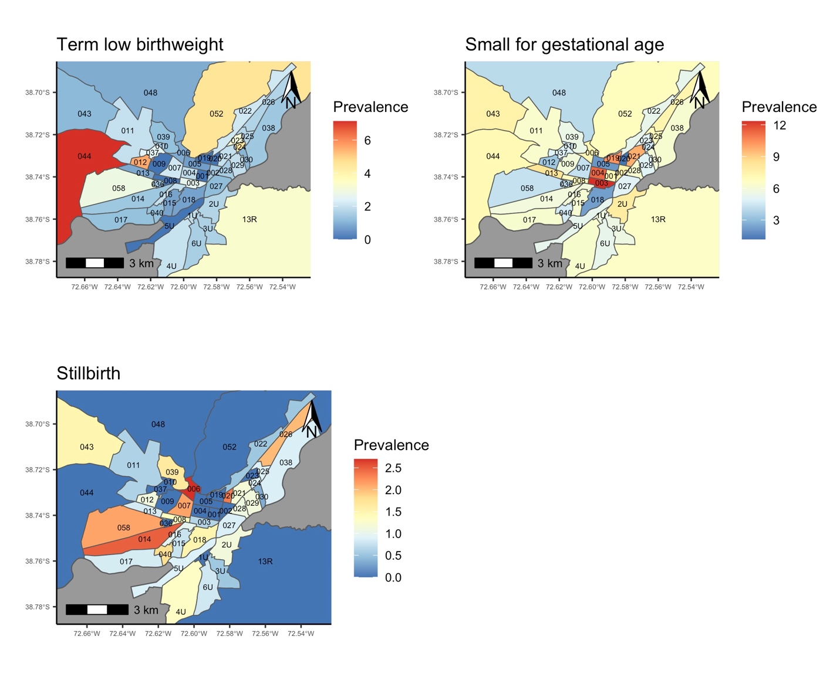

Neighborhoods:

|  |  |  |  |
| --- | --- | --- | --- |
| IU- Villa Alegre | 006- Pedro de Valdivia | 018- Pichi Cautín | 029- Santa Rosa |
| 2U- La Unión | 007- Los Jardines | 019- Lourdes | 030- Pomona |
| 3U- Alianza | 008- Dreves | 020- Tucapel | 036- Estadio |
| 4U- Thiers | 009- Sofo | 021- Maestranza | 037- Campos Deportivos |
| 5U- Ribereños | 010- Los Laureles | 022- 5 de abril | 038- Villa Turingia |
| 6U- Manquehue | 011- Tromen | 023- Ernesto Bohn | 039- Vista Hermosa |
| 001- Central | 012- Igualdad y Trabajo | 024- Ñielol | 040- Villa Sur |
| 002- Estación | 013- Millaray | 025- Evaristo Marín | 043- Tromen Molulco |
| 003- Las Heras | 014- Universidad | 026- Porvenir | 044-Botrolhue |
| 004- Caupolicán | 015- Las Quilas | 027- San Antonio | 050- Pumalal |
| 005- Balmaceda | 016- Imperial | 028- Paredes | 058- José Miguel Carrera |

Supplementary Figure 4 (cont.). Spatial distribution of pre-eclampsia, eclampsia, gestational diabetes, hypertensive disorders, tLBW, stillbirth and SGA by neighborhood, Temuco, Chile, 2009-2016.